ISD TEAM Project –Team 1

**Team Members & Role**

202130397 Lim HyunWoo: Back-end.

202285053 Avalos Gutierrez Juan Ramon: Back-end.

202285044 Li Tzu Ning: Front-end.

**The goal of Project**

It aims to implement a web page where users can inquire movie-related information and compare it simply. For this, we are going to make three functions.

Functions:

1) Search-Function: When a user searches for a title, the corresponding movie information is provided.

2) Filtering: If user choose a genre, user will see movies that fit that genre.

3) Comparison: Choose the movies user wants to compare and show the graph of each movie’s average score.

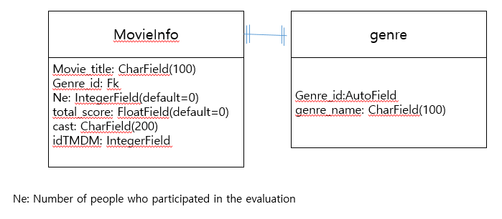**ERD**

Figure 1: ERD

We made an ERD as shown in figure 1 using The Movie Database (TMDB). In movieInfo, it contains the overall movie information. In genre, it includes genre id and genre name. They are linked by genre_id.

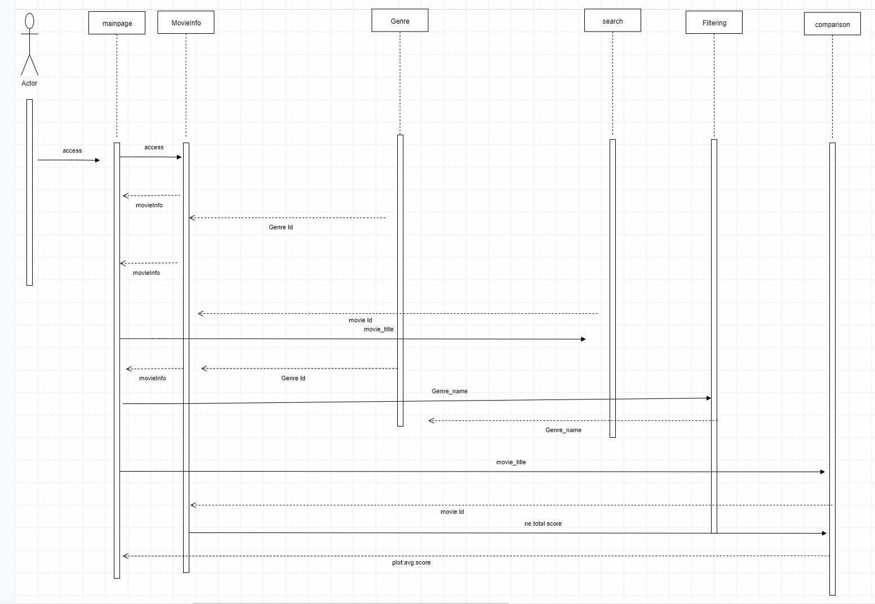**Sequence diagram**

Figure 2: Sequence diagram

The basic function is that, when a user selects a movie, MoiveInfo gives movie-related information, and Genre gives the genre name. When the user enters the title of the movie to utilize ‘Search’ function, the corresponding movie id is entered in MoiveInfo. MovieInfo returns movie information with movie id. User enters genre names to filter movies by genre. 'Genre' delivers the genre ID that matches the genre name entered by the user to MovieInfo. MovieInfo returns movies corresponding to genre id to the user. Using ‘comparison’, user inputs title of the movies. MovieInfo sends the number of evaluators and the total score of the movie. Using the received information, the average score (total score/Ne) for each movie is calculated and displayed in form of a barplot with visualization tools.

**System Architecture**

In the image bellow it is summarized the system architecture and the different connections that exists inside our page.

Figure 3: System architecture.

On one hand, the information from the API of “The movie Database” is requested by the developer to update lists of movies and genres in the local database with list_genres and movie_list views. On the other hand, the user can access to four different pages and in some of them, we use AJAX resources to search available information.

**Implementation**

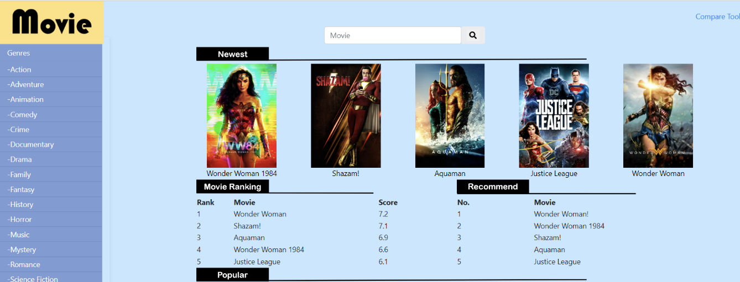Basic function

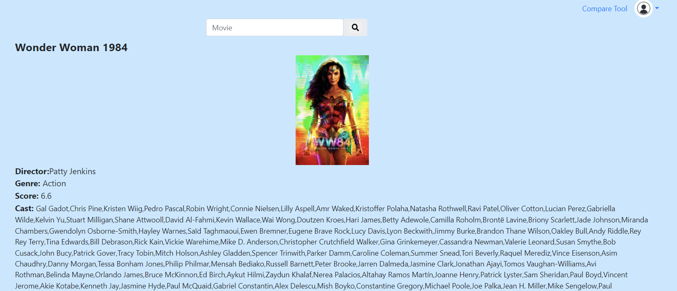

If user clicks the movie title, user will be taken to the movie information page.

Search function

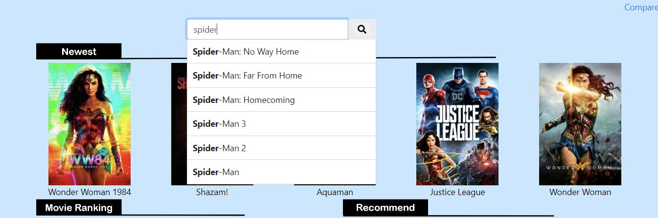

When user types text in the search box, it shows the movie titles that contain the text.

Filtering

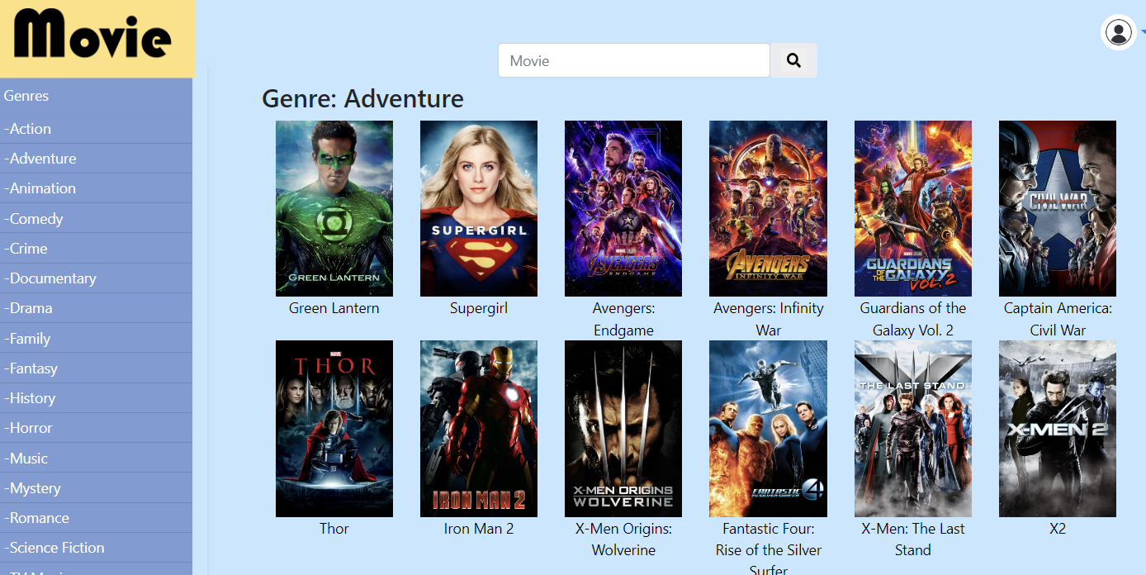

When users clicks on a specific genre, only the movies of that genre are shown.

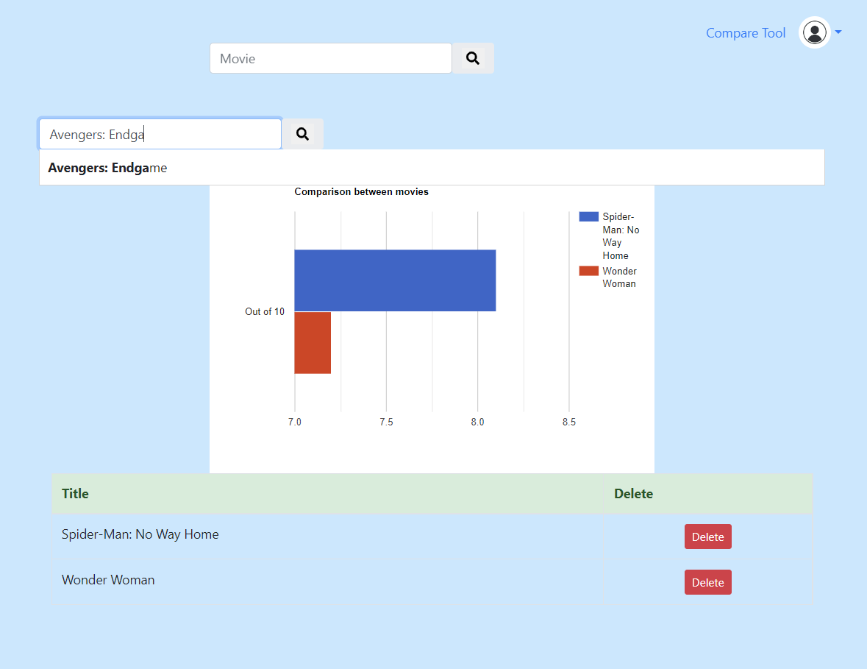

When users click 'Compare Tool', go to the comparison page.

If user enters the movie title, the average score of the movie is shown in the form of a barplot.

Press the 'Delete' key and the corresponding barplot disappears.